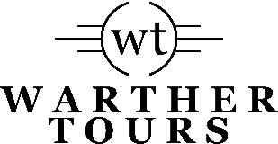
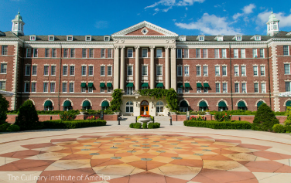

Discover the Hudson River Valley
June 9th – 13th, 2024

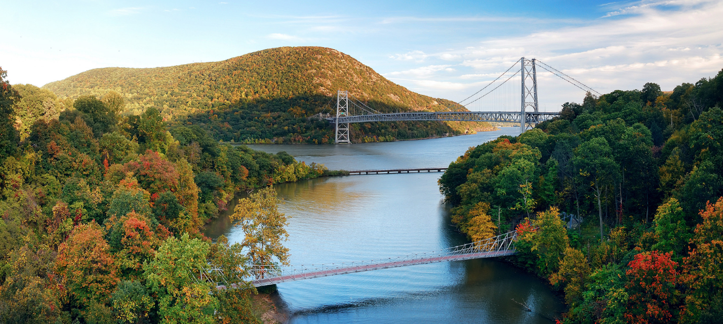
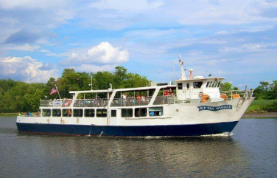
Discover the Hudson River Valley! From history, culture to incredible culinary opportunities, micro-breweries, and wine tasting. There is so much to do. The Hudson Valley is a breath of fresh air—charming visitors from all over the world with its abundance of natural beauty, one-of-a-kind experiences and authentic Americana.

Some Highlights:

Hudson River Cruise
Vanderbilt Mansion
FDR Presidential Library
Culinary Institute of America
West Point
Brotherhood Winery
Ten Meals

Inclusions:
Roundtrip Motorcoach Transportation, Gratuities for Guides and Driver, Luggage Handling

For Registration & Itinerary:

Warther Tours
(330) 556-4535
tours@travelwarther.com

$1995 Per Person Double

$2395 Per Person Single

*Optional Tour Protection Available

Day 1 – June 9, 2024 – Holiday Inn Express, Poughkeepsie
Depart for New York state where upon arrival we will be greeted by our local expert who will personally show us the history and culture of this beautiful valley. Dinner tonight will be at a local favorite, Farmers & Chefs where the food comes straight from local farms. (Dinner)

Day 2 – June 10, 2024 - Holiday Inn Express, Poughkeepsie
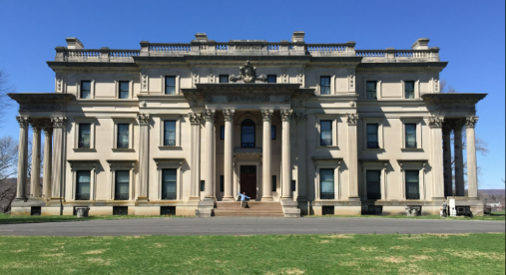
This morning we’ll have a guided tour of Vanderbilt Mansion. Hyde Park was a seasonal residence, one of a portfolio of homes the Vanderbilts owned. The house designed for Frederick and Louise Vanderbilt by McKim, Mead, & White is a masterpiece of American architecture. Though modest compared to the grand houses of Vanderbilt’s siblings, the Hyde Park interiors spared no expense and are richly appointed with exotic wood paneling, imported marble, lush velvets, French tapestries, and, as was the custom, antique building components salvaged from the great houses of Europe.

Lunch is included at Eveready Diner in Hyde Park.

Following our lunch is a guided tour of Springwood, the boyhood home of Franklin D. Roosevelt. Springwood, the birthplace, and home of President Franklin Delano Roosevelt, is the only place in the United States where a President was born, maintained a lifelong connection, and lies buried. Franklin Roosevelt had a strong and abiding connection with Springwood throughout his life.
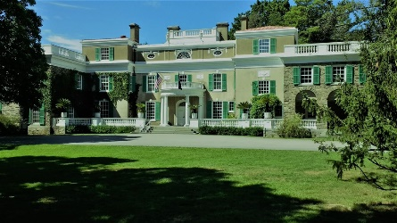
Next, we arrive at the FDR Presidential Library /Museum for a self-guided visit. Explore the special interactives, immersive audio-visual Theatres and rarely seen artifacts that convey the dramatic story of the Roosevelt era.

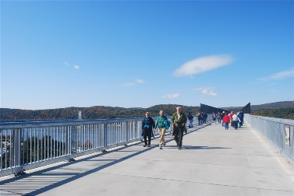
Before our dinner at Coppola’s Italian restaurant in Hyde Park we will enjoy the Walkway over the Hudson. For those that want to walk part of the world’s longest elevated pedestrian bridge will enjoy breathtaking, unobstructed 360-degree views of the river and surrounding scenic valley from 212 feet above the river. (Breakfast, Lunch, Dinner)

Day 3 – June 11, 2024 - Holiday Inn Express, Poughkeepsie
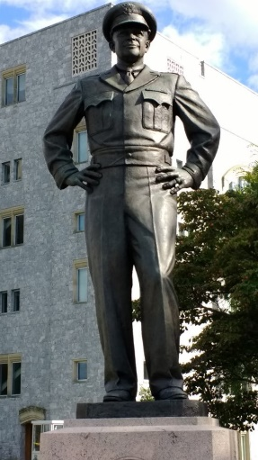
Our first stop of the day is a guided tour of West Point campus. Hear the story of West Point and the United States Military Academy beginning in 1778 during the Revolutionary War, to the present role of the United States Military Academy as the premier training facility for leaders who mold the future of our country. Along the way, historical figures such as George Washington, Thomas Jefferson, Dwight Eisenhower, and even Benedict Arnold help bring the story of West Point and our nation to life. The tour makes stops at Trophy Point, Battle Monument, the Plain and the Cadet Chapel.

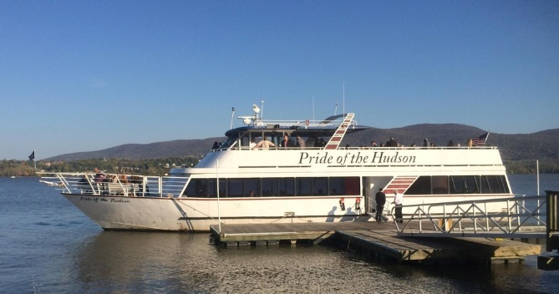
Following our West Point morning we can relax and enjoy a two-hour cruise on board the “Pride of the Hudson” with a light lunch included.

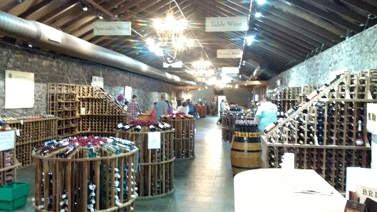
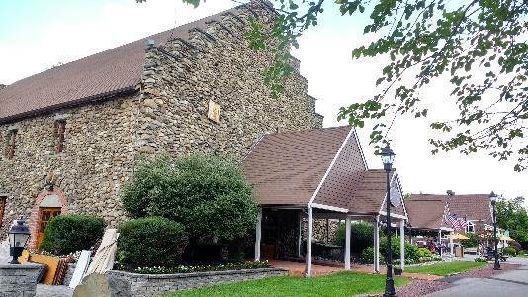
We wrap up our day in the Hudson River Valley with a guided tour and tasting at Brotherhood Winery, America's oldest winery. Experience the historic atmosphere of Brotherhood Winery by taking a leisurely stroll through the vast network of underground cellars. Excavated by hand in the late 19th Century, the dimly lit cellars house over two hundred oak barrels and feature a crested vault containing some of the oldest vintages in America. Your guide will reveal the secrets of these mysterious vaults and keep you amused with tall tales of folly and tragedy. Test your wine tasting skills in our modern showroom and enjoy the many flavors and textures Brotherhood has to offer the budding and discerning wine lover. Dinner will be at the River Grill. (Breakfast, Lunch, Dinner)

Day 4 – June 12, 2024 - Holiday Inn Express, Poughkeepsie
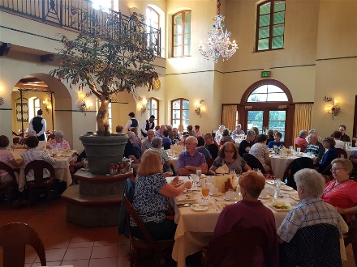
Start your day with a CIA Experience at the Culinary Institute of America. Here we will meet with students, enjoy lunch and a unique tasting exercise, and take a tour of the main building's teaching area.

Next stop, Mills Mansion for a guided tour of the gilded age. This state historic site is emblematic of the great country estates built to house America’s wealthiest families.
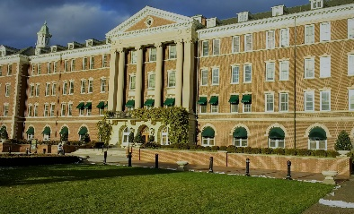
Dinner will be on your own this evening in the vibrant historic town of Rhinebeck. Choose from Rhinebeck’s wide range of cuisines, centered around their active farm-to-table movement. (Breakfast, Lunch)

Day 5 – June 13, 2024 - Home
Depart for home with beautiful memories of the Hudson River Valley. (Breakfast)

